**Project Report**





**SubmittedBy:**

Lakshay Baweja: 17CSU093

Kartik Luthra: 17CSU088

Kaushal Kishore:17CSU090

**MAIL AND WEB SERVER**

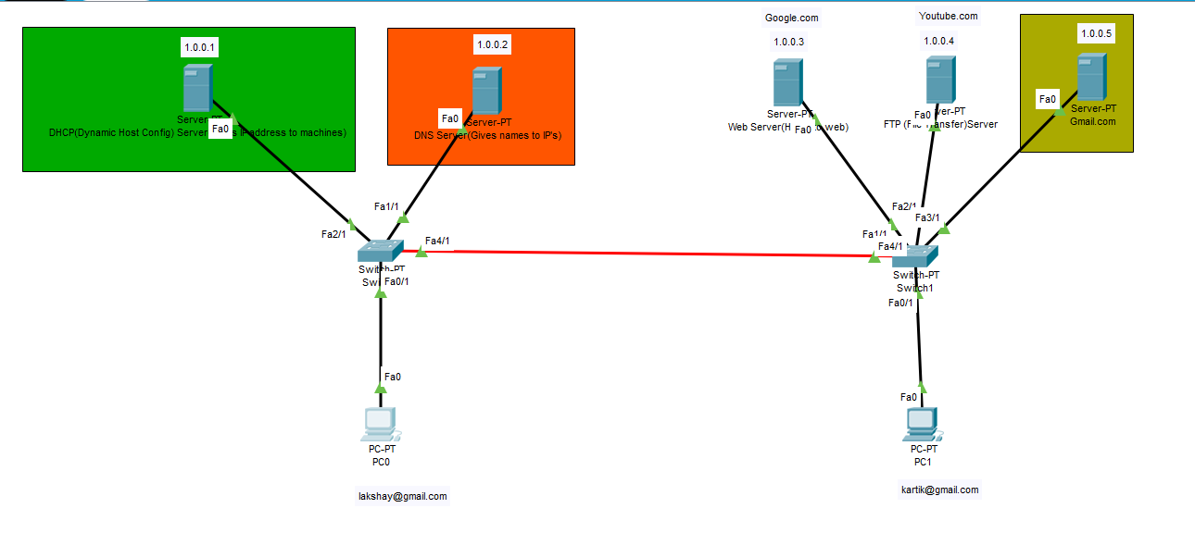

**DHCP:-**

The **Dynamic Host Configuration Protocol** (**DHCP**) is a [network management protocol](https://en.wikipedia.org/wiki/Network_protocol) used on [UDP/IP](https://en.wikipedia.org/wiki/UDP/IP) networks whereby a DHCP server dynamically assigns an [IP address](https://en.wikipedia.org/wiki/IP_address) and other network configuration parameters to each device on a network so they can communicate with other IP networks.[[1]](https://en.wikipedia.org/wiki/Dynamic_Host_Configuration_Protocol#cite_note-TechTarget-1) A DHCP server enables computers to request IP addresses and networking parameters automatically from the [Internet service provider](https://en.wikipedia.org/wiki/Internet_service_provider) (ISP), reducing the need for a [network administrator](https://en.wikipedia.org/wiki/Network_administrator) or a user to manually assign IP addresses to all network devices.

DHCP can be implemented on networks ranging in size from [home networks](https://en.wikipedia.org/wiki/Home_network) to large [campus networks](https://en.wikipedia.org/wiki/Campus_network) and regional [Internet service provider](https://en.wikipedia.org/wiki/Internet_service_provider) networks.[[2]](https://en.wikipedia.org/wiki/Dynamic_Host_Configuration_Protocol#cite_note-2) A [router](https://en.wikipedia.org/wiki/Router_(computing)) or a [residential gateway](https://en.wikipedia.org/wiki/Residential_gateway) can be enabled to act as a DHCP server. Most residential network routers receive a globally unique IP address within the ISP network. Within a local network, a DHCP server assigns a local IP address to each device connected to the network.

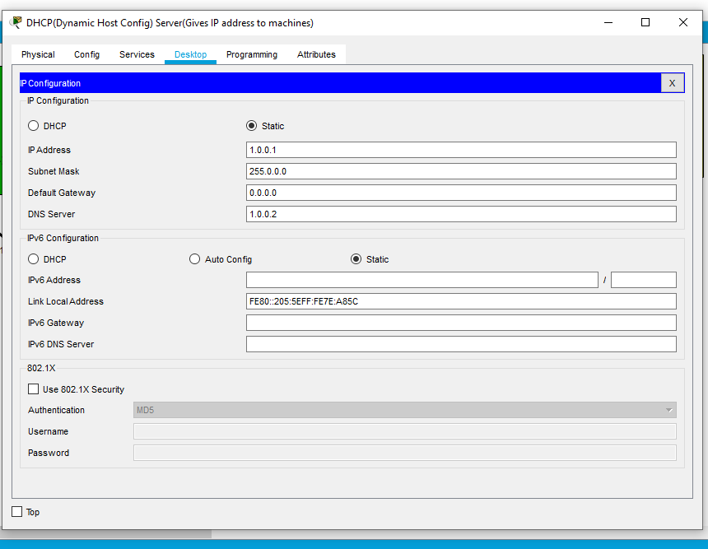

**DNS:-**

The Domain Name System (DNS) is the phonebook of the Internet. Humans access information online through domain names, like nytimes.com or espn.com. Web browsers interact through Internet Protocol (IP) addresses. DNS translates domain names to [IP addresses](https://www.cloudflare.com/learning/dns/glossary/what-is-my-ip-address/) so browsers can load Internet resources.

Each device connected to the Internet has a unique IP address which other machines use to find the device. DNS servers eliminate the need for humans to memorize IP addresses such as 192.168.1.1 (in IPv4), or more complex newer alphanumeric IP addresses such as 2400:cb00:2048:1::c629:d7a2 (in IPv6).

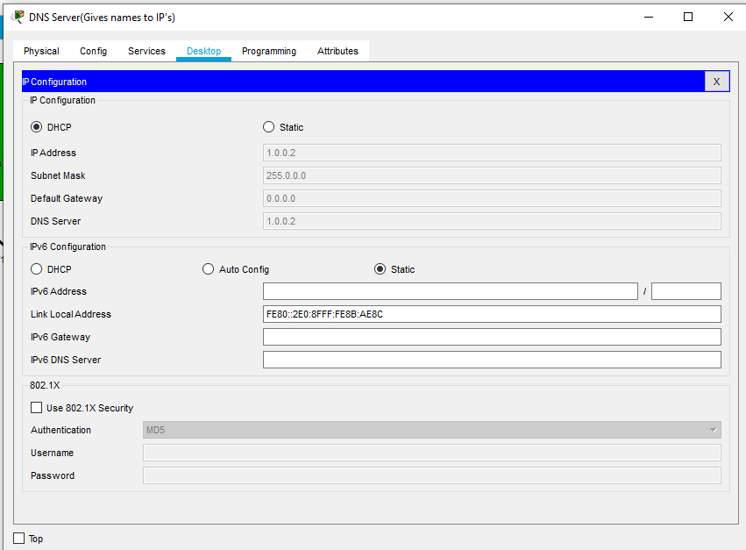

**Web Server:-**

A **web server** is [server software](https://en.wikipedia.org/wiki/Server_software), or hardware dedicated to running said software, that can satisfy [World Wide Web](https://en.wikipedia.org/wiki/World_Wide_Web) client requests. A web server can, in general, contain one or more [websites](https://en.wikipedia.org/wiki/Website). A web server processes incoming [network](https://en.wikipedia.org/wiki/Computer_network) requests over [HTTP](https://en.wikipedia.org/wiki/Hypertext_Transfer_Protocol) and several other related [protocols](https://en.wikipedia.org/wiki/Communication_protocol).

The primary function of a web server is to store, process and deliver [web pages](https://en.wikipedia.org/wiki/Web_page) to [clients](https://en.wikipedia.org/wiki/Client_(computing)).[[1]](https://en.wikipedia.org/wiki/Web_server#cite_note-1) The communication between client and server takes place using the [Hypertext Transfer Protocol (HTTP)](https://en.wikipedia.org/wiki/Hypertext_Transfer_Protocol). Pages delivered are most frequently [HTML documents](https://en.wikipedia.org/wiki/HTML), which may include [images](https://en.wikipedia.org/wiki/Image), [style sheets](https://en.wikipedia.org/wiki/Style_sheet_(web_development)) and [scripts](https://en.wikipedia.org/wiki/JavaScript) in addition to the text content.

A [user agent](https://en.wikipedia.org/wiki/User_agent), commonly a [web browser](https://en.wikipedia.org/wiki/Web_browser) or [web crawler](https://en.wikipedia.org/wiki/Web_crawler), initiates communication by making a [request](https://en.wikipedia.org/wiki/Hypertext_Transfer_Protocol#Request_message) for a specific resource using HTTP and the server responds with the content of that resource or an [error message](https://en.wikipedia.org/wiki/List_of_HTTP_status_codes#4xx_Client_Error) if unable to do so. The resource is typically a real file on the server's [secondary storage](https://en.wikipedia.org/wiki/Secondary_memory), but this is not necessarily the case and depends on how the web server is [implemented](https://en.wikipedia.org/wiki/Implementation).

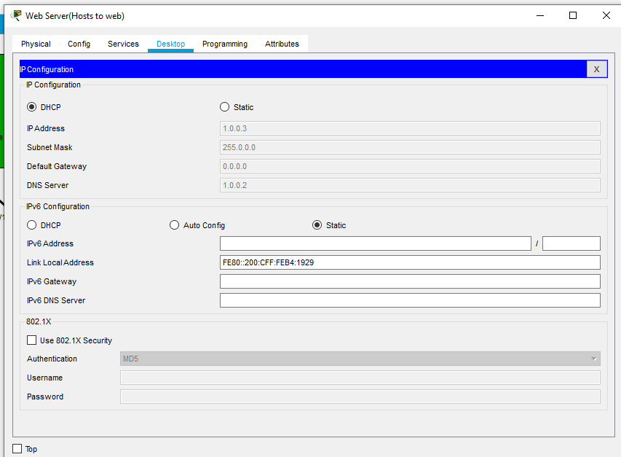

**FTP:-**

The **File Transfer Protocol** (**FTP**) is a standard [network protocol](https://en.wikipedia.org/wiki/Network_protocol) used for the transfer of [computer files](https://en.wikipedia.org/wiki/Computer_file) between [a client and server](https://en.wikipedia.org/wiki/Client%E2%80%93server_model) on a [computer network](https://en.wikipedia.org/wiki/Computer_network).

FTP is built on a client-server model architecture using separate control and data connections between the client and the server.[[1]](https://en.wikipedia.org/wiki/File_Transfer_Protocol#cite_note-for-1) FTP users may authenticate themselves with a [clear-text](https://en.wikipedia.org/wiki/Clear_text) sign-in protocol, normally in the form of a username and password, but can connect anonymously if the server is configured to allow it. For secure transmission that protects the username and password, and encrypts the content, FTP is often [secured](https://en.wikipedia.org/wiki/File_Transfer_Protocol#Security) with [SSL/TLS](https://en.wikipedia.org/wiki/Transport_Layer_Security) ([FTPS](https://en.wikipedia.org/wiki/FTPS)) or replaced with [SSH File Transfer Protocol](https://en.wikipedia.org/wiki/SSH_File_Transfer_Protocol) (SFTP).

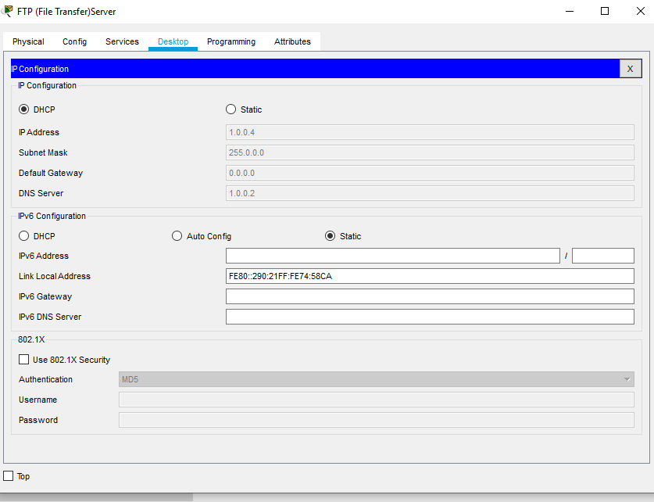

**SMTP:-**

The **Simple Mail Transfer Protocol** (**SMTP**) is a [communication protocol](https://en.wikipedia.org/wiki/Communication_protocol) for [electronic mail](https://en.wikipedia.org/wiki/Email) transmission. As an [Internet standard](https://en.wikipedia.org/wiki/Internet_standard), SMTP was first defined in 1982 by [RFC](https://en.wikipedia.org/wiki/Request_for_Comments_(identifier)) [821](https://tools.ietf.org/html/rfc821), and updated in 2008 by [RFC](https://en.wikipedia.org/wiki/Request_for_Comments_(identifier)) [5321](https://tools.ietf.org/html/rfc5321) to [Extended SMTP](https://en.wikipedia.org/wiki/Extended_SMTP) additions, which is the protocol variety in widespread use today. Mail servers and other [message transfer agents](https://en.wikipedia.org/wiki/Message_transfer_agent) use SMTP to send and receive mail messages. Proprietary systems such as [Microsoft Exchange](https://en.wikipedia.org/wiki/Microsoft_Exchange_Server) and [IBM Notes](https://en.wikipedia.org/wiki/IBM_Notes) and [webmail](https://en.wikipedia.org/wiki/Webmail) systems such as [Outlook.com](https://en.wikipedia.org/wiki/Outlook.com), [Gmail](https://en.wikipedia.org/wiki/Gmail) and [Yahoo! Mail](https://en.wikipedia.org/wiki/Yahoo!_Mail) may use non-standard protocols internally, but all use SMTP when sending to or receiving email from outside their own systems. SMTP servers commonly use the [Transmission Control Protocol](https://en.wikipedia.org/wiki/Transmission_Control_Protocol) on [port number](https://en.wikipedia.org/wiki/Port_number) 25.

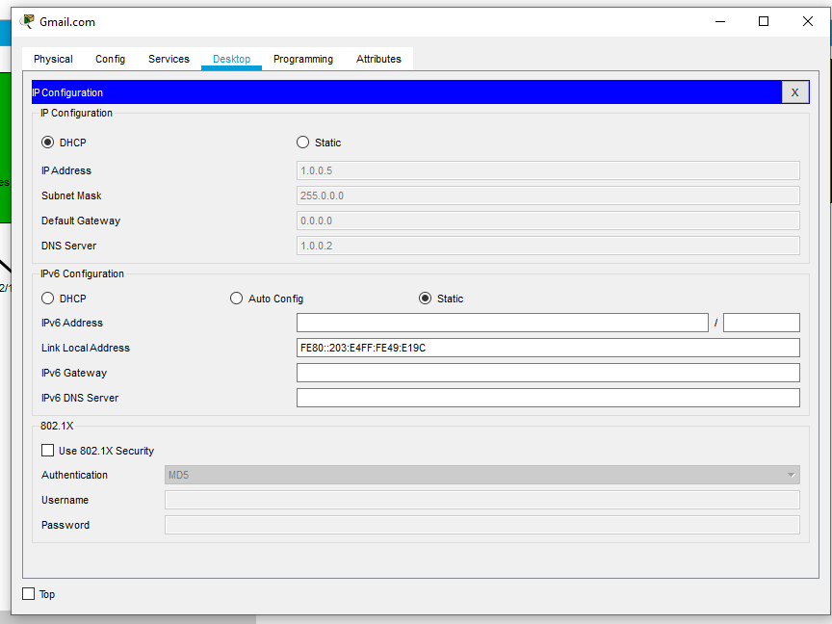

**POP3:-**

The Post Office Protocol provides access via an [Internet Protocol](https://en.wikipedia.org/wiki/Internet_Protocol) (IP) network for a user client application to a mailbox (*maildrop*) maintained on a mail server. The protocol supports download and delete operations for messages. POP3 clients connect, retrieve all messages, store them on the client computer, and finally delete them from the server.[[2]](https://en.wikipedia.org/wiki/Post_Office_Protocol#cite_note-Windows_to_Linux-2) This design of POP and its procedures was driven by the need of users having only temporary Internet connections, such as [dial-up access](https://en.wikipedia.org/wiki/Dial-up_Internet_access), allowing these users to retrieve e-mail when connected, and subsequently to view and manipulate the retrieved messages when offline.

POP3 clients also have an option to leave mail on the server after download. By contrast, the [Internet Message Access Protocol](https://en.wikipedia.org/wiki/Internet_Message_Access_Protocol) (IMAP) was designed to normally leave all messages on the server to permit management with multiple client applications, and to support both connected (*online*) and disconnected (*offline*) modes of operation.

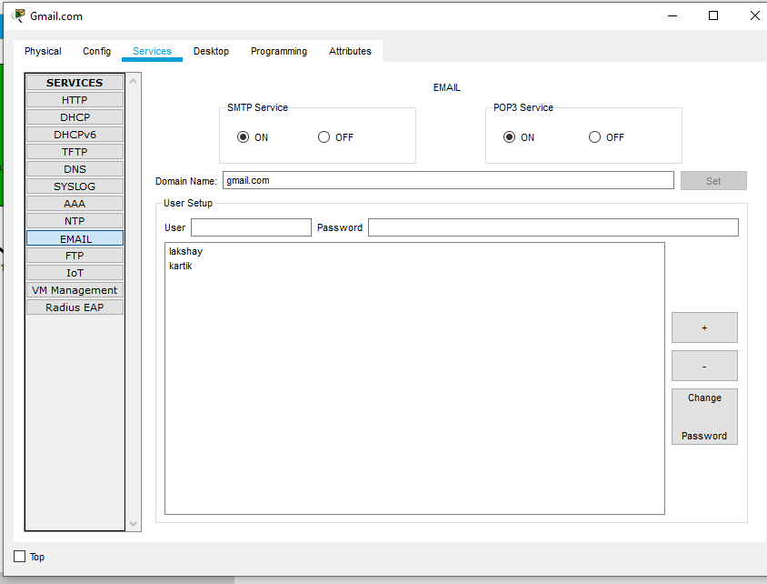

**Result:-**

**Mail Send:-**

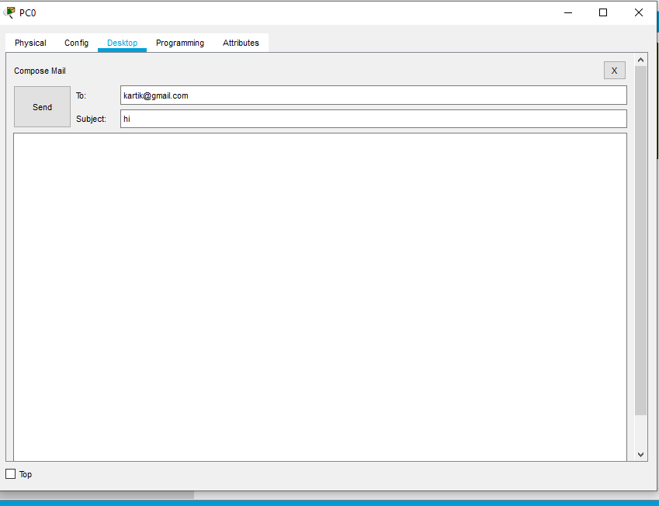

**Mail Receive-**

